LABIA – FACTSHEET
The vulva refers to all female genitals. The vagina refers to the inner canal that runs from the cervix to the vaginal opening. There are two types of labia (sometimes called lips) – inner and outer.

See below the different types of labia:
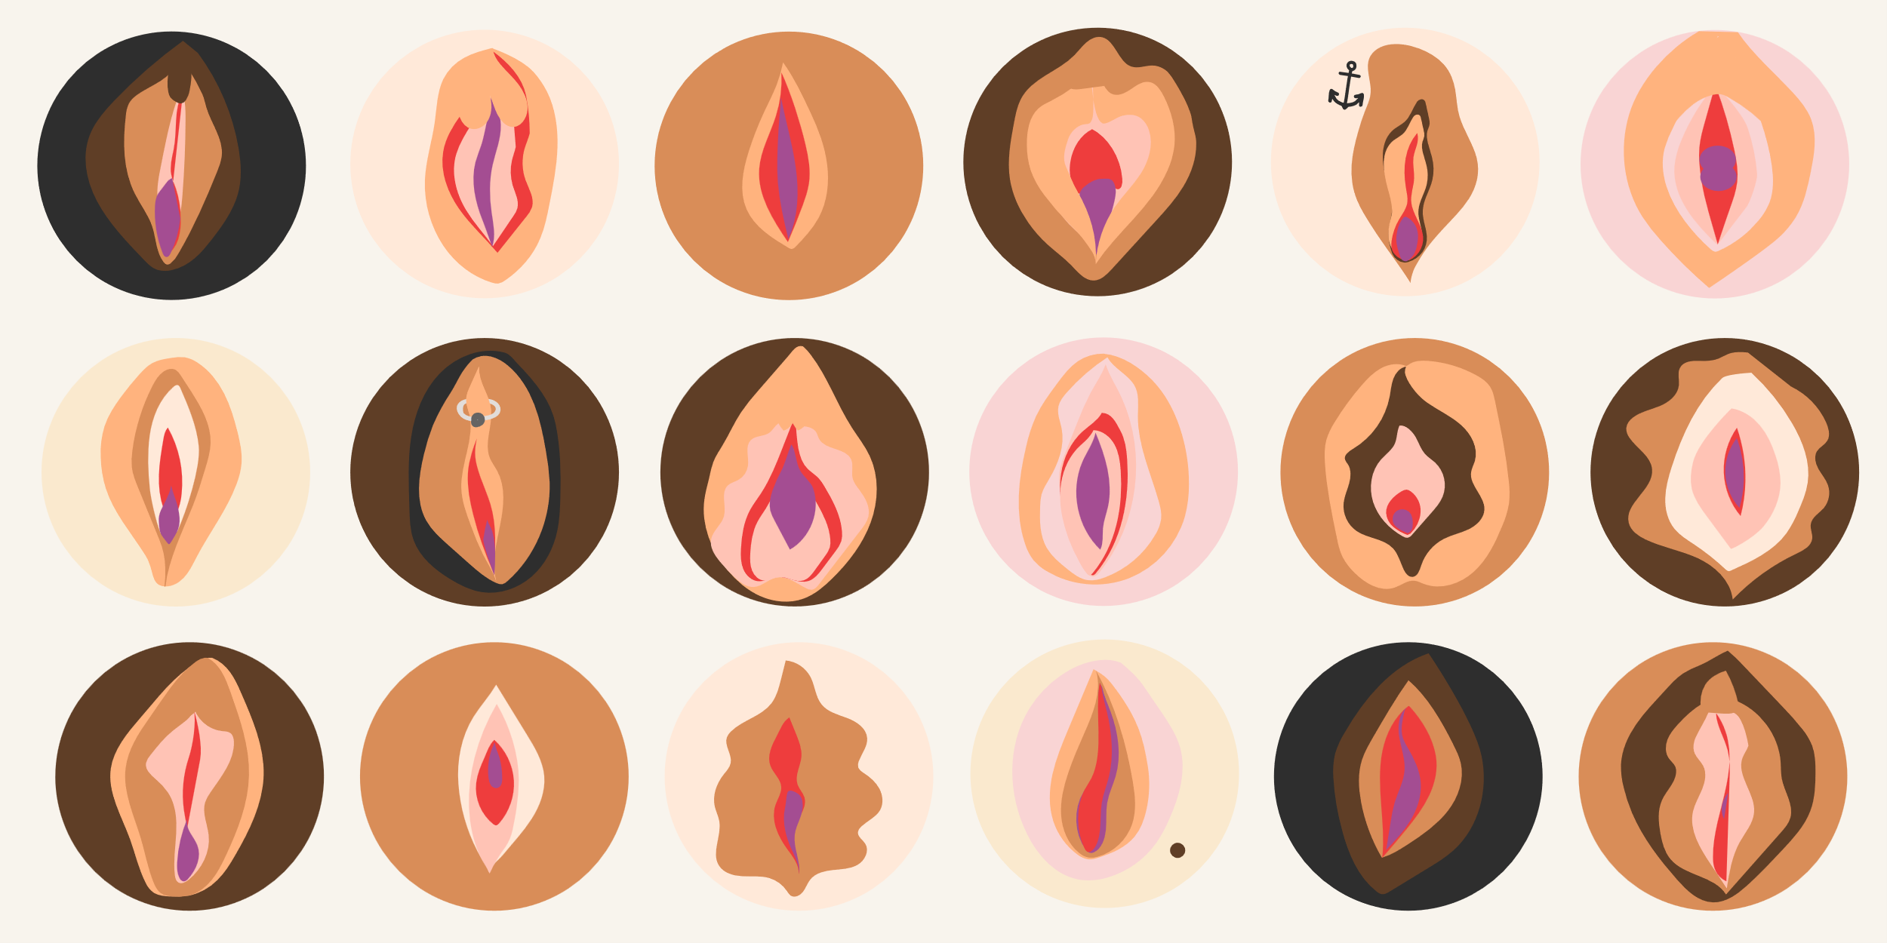
Every shape, size and colour - all completely normal and natural.

Facts about labia:
- It is normal to have hair on your labia.
- The types of labia in pornographic images or videos are less common than other types of labia.
- The labia minora (inner lips) is more sensitive than your labia majora (outer lips). This should only ever be washed with water and not soaps or products.
- Your labia can change colour throughout the day.
- Sex does not change the shape of your labia.
- Labia protect your vagina and urethra from harm – so love your labia. They do a lot for you.

